April 14, 2022

Dear Parents:

We are excited about the upcoming 22nd year of “RevTab Youth Camp 2022”, at Mount Camp Luther in beautiful Mifflinburg, Pennsylvania, July 25th – July 29th. Our Theme this year is, RevTab Youth Camp Extreme edition.

Camp Luther is a fabulous facility on 400 acres in north/central PA. The Registration fee is $250, ($200 if received before June 15th) and includes all activities and meals. A free T-Shirt will be given to every camper who pays in full by June 15th. Additional T-shirts will be available for $10.00 and canteen cards will be available for $5, $10, $15 or $20. Check-in is from 10 a.m. to noon on Monday, July 22nd and checkout is by 2 p.m. on Friday, July 26th. Because we take the safety of our campers so seriously, counselors will have a Child Abuse Clearance and Criminal History Background Check on file. If you would like to volunteer at camp, please complete the Staff Application included in this packet and give to your church’s Camp Coordinator.

Please consider this a personal invitation for your child, ages 8 through 18, to attend this fun-filled yet spiritually uplifting event! Activities include: volleyball, basketball, softball, swimming in an Olympic sized pool, crafts, archery, canoeing, fishing and hiking, morning devotions and an evening service with an emphasis on developing greater relationship with Christ. A licensed nurse will be on-site to dispense medications and provide a medically safe environment. There are several RV campgrounds nearby along with local hotels. Call the church office at 570-538-2000 for rates and reservations. Your child will return home renewed in the Lord and ready for the school year!

Please direct any questions you may have to your church’s Camp Coordinator or call us at the number above. We are looking forward to a great year at Youth Camp! See you there!

In His Service,
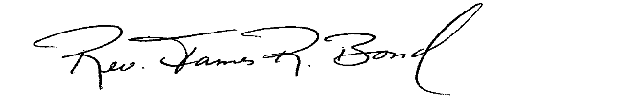
Rev. James R. Bond
Camp Director

Enc.

